# PIZZA SALES SQL QUERIES

1. KPI’S
2. Total_revenue:

SELECT SUM(total_price) AS total_revenue from pizza_sales

1. Avg_ordervalue:

SELECT SUM(total_price) / COUNT(distinct order_id) as avg_ordervalue from pizza_sales

1. Total_pizzasold:

SELECT SUM(quantity) as total_pizzasold from pizza_sales

1. Total_orders

SELECT COUNT(distinct order_id) as total_orders from pizza_sales

1. Average_pizzaordered:

SELECT CAST(CAST(SUM(quantity) AS DECIMAL(10,2)) /

CAST(count(distinct order_id) AS DECIMAL(10,2)) AS DECIMAL(10,2)) from pizza_sales

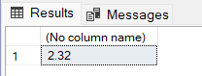

1. Daily trends for total order:

SELECT DATENAME(DW, order_date) as order_day , COUNT(DISTINCT order_id) as total_order

FROM pizza_sales

GROUP BY DATENAME(DW, order_date)

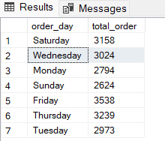

1. Monthly trends for total orders:

SELECT DATENAME(MONTH, order_date) as order_Month , COUNT(DISTINCT order_id) as total_order

FROM pizza_sales

GROUP BY DATENAME(MONTH, order_date)

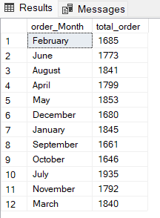

1. Pizza category with percentage of total sales:

SELECT pizza_category, sum(total_price) * 100 / (SELECT SUM(total_price) from pizza_sales)

FROM pizza_sales

GROUP BY pizza_category

1. Pizza size with percentage of total sales:

SELECT pizza_size, sum(total_price) * 100 / (SELECT SUM(total_price) from pizza_sales)

FROM pizza_sales

GROUP BY pizza_size

1. Top 5 bestseller pizza:

SELECT TOP 5 pizza_name, Sum(total_price) AS total_revenue FROM pizza_sales

GROUP BY pizza_name

ORDER BY total_revenue DESC

1. Bottom 5 pizza

SELECT TOP 5 pizza_name, Sum(total_price) AS total_revenue FROM pizza_sales

GROUP BY pizza_name

ORDER BY total_revenue ASC

